|  |  |
| --- | --- |
|  | **DEPARTMENT OF COMPUTER ENGINEERING** |

**DBMS Mini-Project**

|  |  |
| --- | --- |
| Semester | S.E. Semester IV – Computer Engineering |
| Subject | Data Base Management System |
| Subject Professor In-charge | Prof. Suja Jayachandran |
| Assisting Teachers | Prof. Suja Jayachandran |

|  |  |
| --- | --- |
| Roll Numbers | Name of Students |
| 21102A0003 | Omkar Patil |
| 21102A0005 | Pranav Redij |
| 21102A0014 | Deep Salunkhe |
| 21102A0015 | Gauri Naik |

**Name of the Project: ICC DATABASE**

**Project Code:**

|  |
| --- |
| create table users(u_id varchar primary key,u_name varchar,u_addr varchar,u_mail_id varchar,u_phone varchar);  create table team(t_id varchar primary key,t_name varchar,t_records varchar);  create table league(l_id varchar primary key,l_name varchar,l_origin varchar,b_id varchar,l_period date);  create table board(b_id varchar primary key,b_name varchar,b_organisation varchar);  create table played_in(l_id varchar,u_id varchar);  create table played_for(u_id varchar,t_id varchar);  create table role(r_id varchar primary key,r_name varchar);  create table taught(u_id varchar,t_id varchar);  create table participate(l_id varchar,t_id varchar);  create table is_a(u_id varchar,r_id varchar);  alter table league  add foreign key(b_id)  references board(b_id)  on update cascade;  alter table is_a  add foreign key(r_id)  references role(r_id)  on update cascade;  alter table is_a  add foreign key(u_id)  references users(u_id)  on update cascade;  alter table played_in  add foreign key(l_id)  references league(l_id)  on update cascade;  alter table played_in  add foreign key(u_id)  references users(u_id)  on update cascade;  alter table played_for  add foreign key(u_id)  references users(u_id)  on update cascade;  alter table played_for  add foreign key(t_id)  references team(t_id)  on delete cascade;  alter table taught  add foreign key(u_id)  references users(u_id)  on update cascade;  alter table taught  add foreign key(t_id)  references team(t_id)  on update cascade;  alter table participate  add foreign key(l_id)  references league(l_id)  on update cascade;  alter table participate  add foreign key(t_id)  references team(t_id)  on update cascade;  insert into users values('p1','sachin_tendulkar','bandra(w)','sachin@mail.com','2226457576');  insert into users values('p2','virat_kohli','worli','virat@mail.com','4426457576');  insert into users values('c1','ramakant_achrekar','dadar','ram@mail.com','4526457576');  insert into users values('c2','rajkumar_sharma','delhi','raj@mail.com','4547457576');  insert into users values('p3','mahendrasingh_dhoni','ranchi','mahendra@mail.com','2226857576');  insert into users values('p4','hardik_pandya','vadodara','hardik@mail.com','4426457876');  insert into team values('t1','star','ipl 2021 won');  insert into team values('t2','moon','worldcup 2017 won');  insert into team values('t3','astroids','ipl 2020 won');  insert into team values('t4','sun','worldcup 2021 winner');  insert into league values('l1','ipl','india','b1','4-07-2022');  insert into league values('l2','icl','india','b2','5-08-2022');  insert into league values('l3','wpl','india','b1','4-05-2021');  insert into board values('b1','bcci','private');  insert into board values('b2','icc','private');  insert into role values('r1','captain');  insert into role values('r2','batsmam');  insert into role values('r3','goalkeeper');  insert into role values('r4','bowler');  insert into role values('r5','allrounder');  insert into played_in values('l1','p1');  insert into played_in values('l1','p2');  insert into played_in values('l2','p1');  insert into played_in values('l3','p4');  insert into played_for values('p1','t1');  insert into played_for values('p1','t2');  insert into played_for values('p2','t1');  insert into played_for values('p3','t3');  insert into played_for values('p4','t3');  insert into played_for values('p4','t4');  insert into taught values('c1','t1');  insert into taught values('c2','t2');  insert into participate values('l1','t1');  insert into participate values('l1','t2');  insert into participate values('l2','t1');  insert into participate values('l3','t3');  insert into is_a values('p1','r1');  insert into is_a values('p2','r3');  insert into is_a values('p3','r4');  insert into is_a values('p2','r2');  select * from users;  select * from team;  select * from league;  select * from board;  select * from played_in;  select * from played_for;  select * from role;  select * from is_a;  select * from participate;  select l_id from league  where l_period between '01-01-2021' and '31-12-2022';  create view team_records as  select team.t_id,team.t_name,league.l_name,league.l_id  from team,league  group by team.t_id,league.l_id  order by count(l_id);  select * from team_records;  SELECT u_id FROM played_in  WHERE l_id='l1';  select l_id from league  right join board  on league.b_id=board.b_id;  select l_id from league  full outer join board  on league.b_id=board.b_id; |

**Result/ Output:**

USERS TABLE:

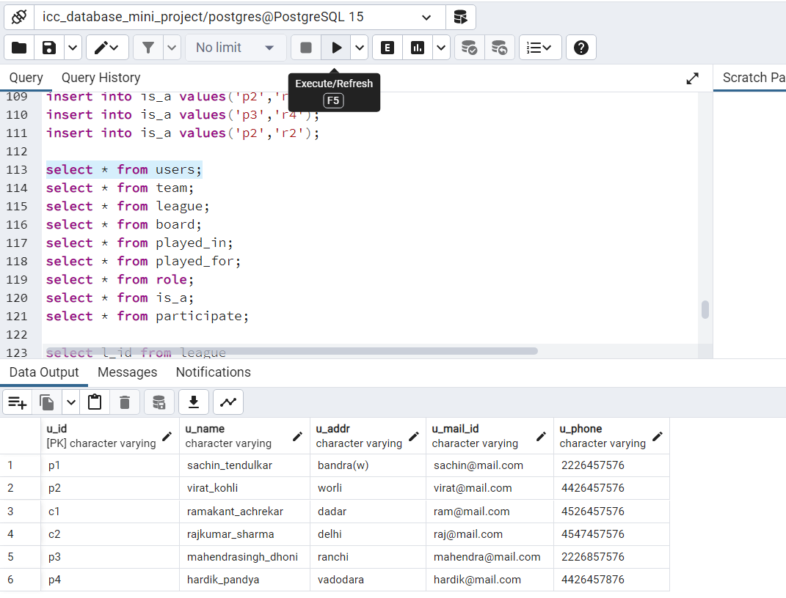

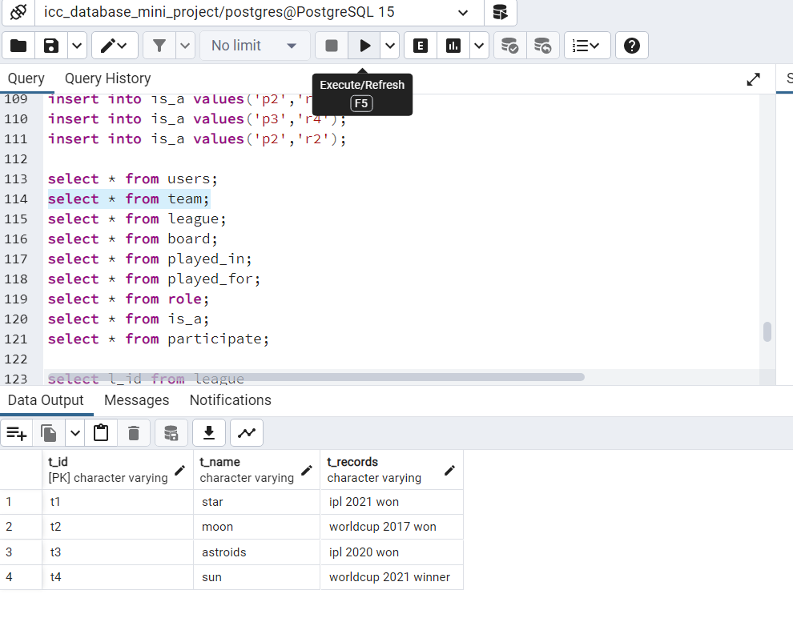TEAM TABLE:

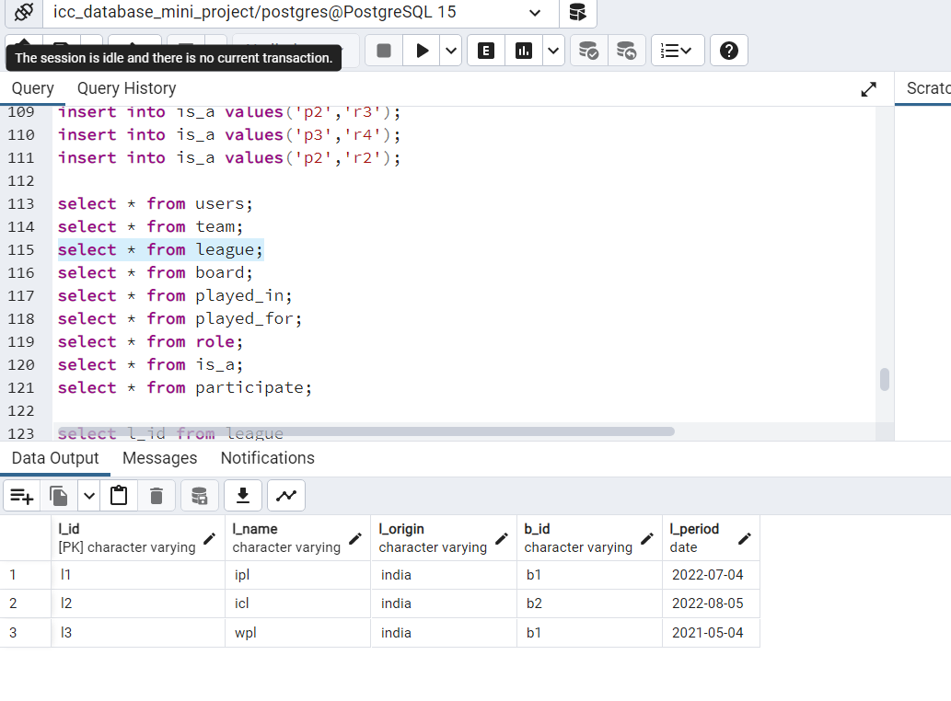LEAGUE TABLE:

BOARD TABLE:

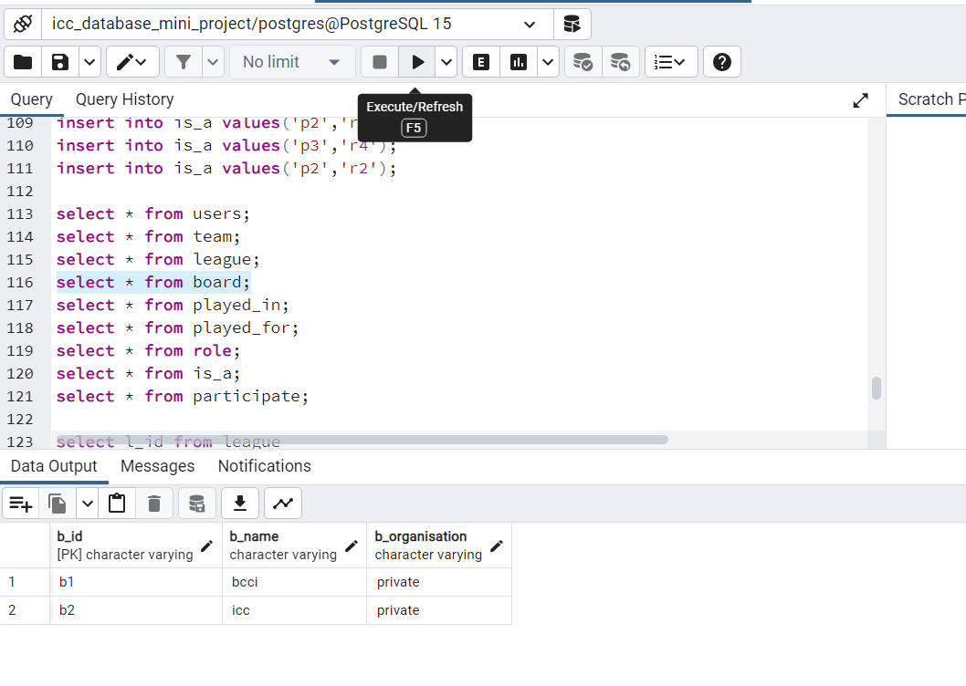

PLAYED_IN TABLE:

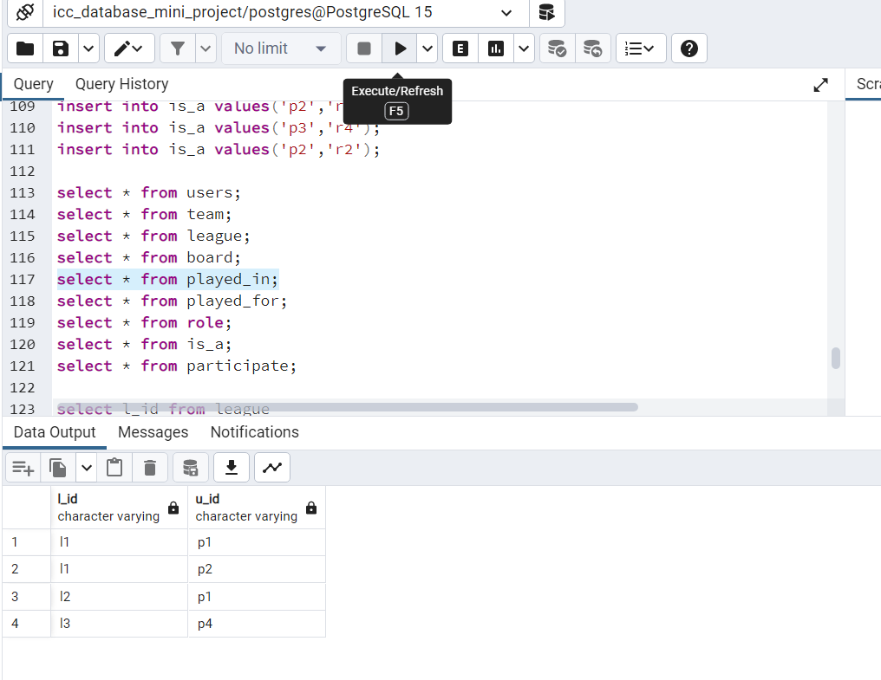

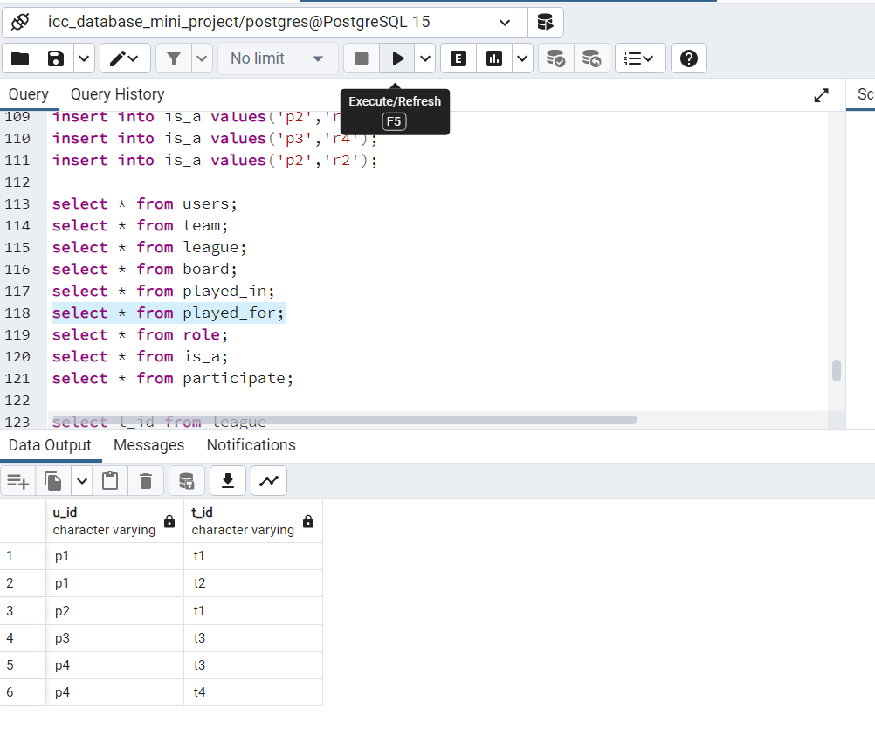PLAYED_FOR TABLE:

ROLE TABLE:

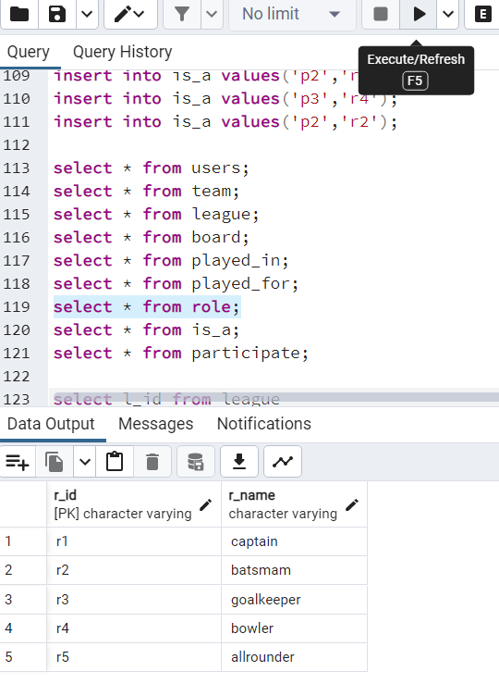

PARTICIPATE

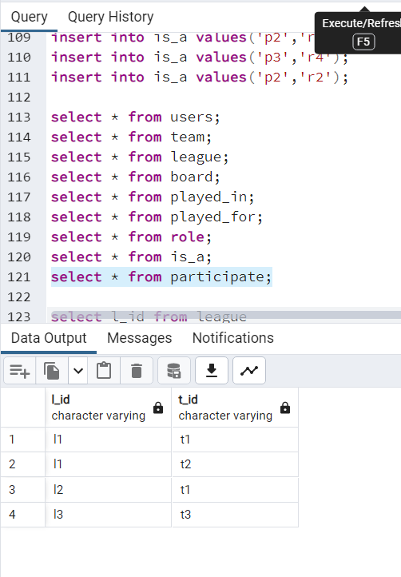PARTICIPATE TABLE:

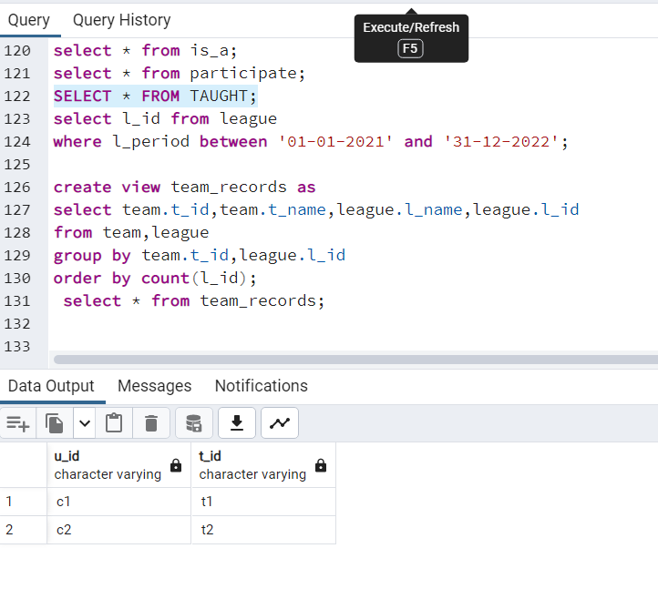TAUGHT TABLE:

What is the SQL query to retrieve the **l_id** values from the **league** table for all leagues that were active between January 1, 2021, and December 31, 2022?

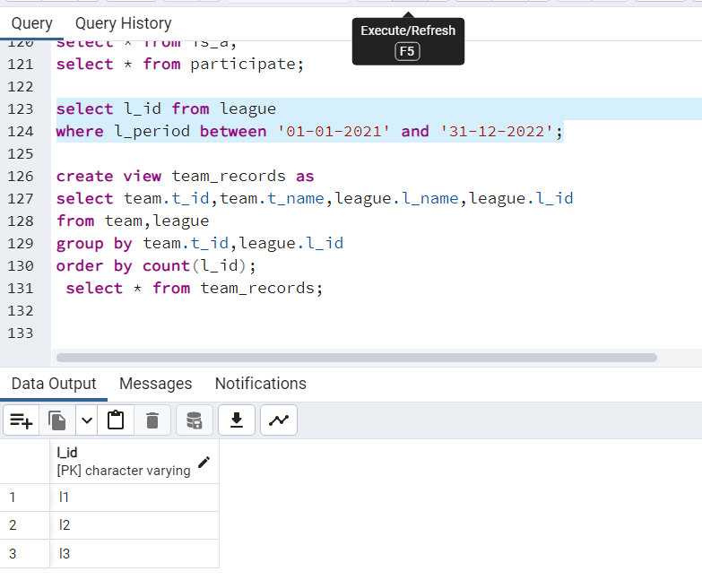

What is the SQL code to create a view called **team_records** that displays the **t_id**, **t_name**, **l_name**, and **l_id** columns from the **team** and **league** tables, grouped by **t_id** and **l_id**, and ordered by the count of **l_id**? Also, what is the SQL query to select and display all columns from the **team_records** view?

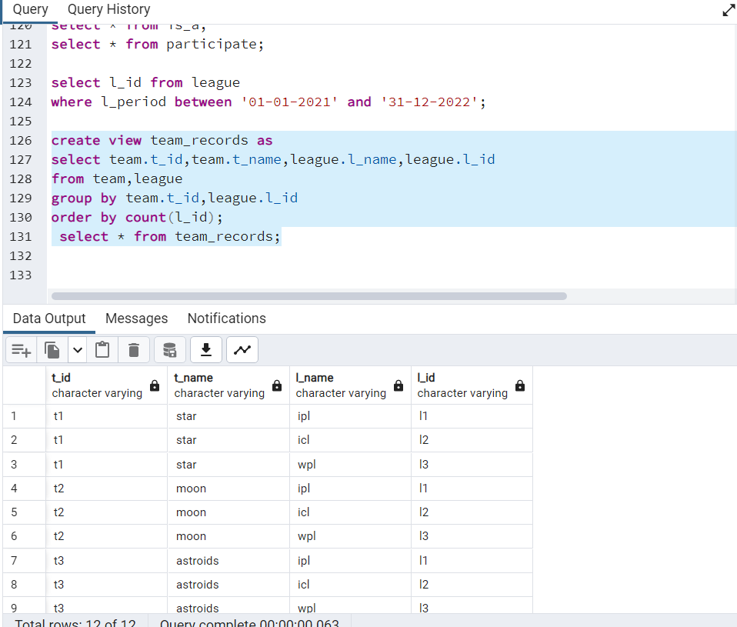

1. What is the SQL query to select the **u_id** values from the **played_in** table for all users who played in a league with **l_id** equal to **'l1'**?

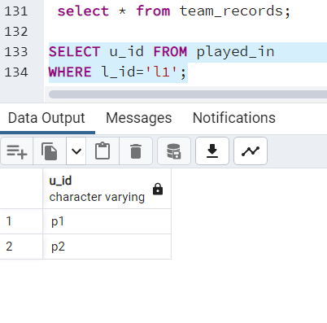

RIGHT JOIN: What is the SQL query to select the **l_id** values from the **league** table for all leagues associated with a board using a **right join** with the **board** table?

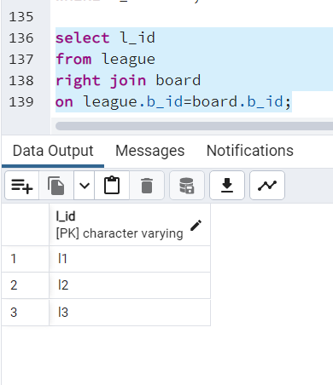

What is the SQL query to select the **l_id** values from the **league** table for all leagues associated with a board using a **full outer join** with the **board** table?

